**Name : Ketan Chandrakant Dehankar**

**I have written 2 solutions for this problem statement. I have used python 3 for coding part.**

1. **Calorie calculator**

**Maintaining a healthy lifestyle has been one of the main concerns of this century. According to WHO in 2016, more than 1.9 billion adults, 18 years and older, were overweight. Of these over 650 million were obese. With the covid-19 outbreak this year it has been proved that covid-19 is more fatal to people with obesity. So regular exercise and healthy diet is an important thing people are looking into. With this in mind, I thought how about I make a calorie tracker with python .**

**You can count how much calorie you have taken particular week or day. It will help you to manage your health good .it will tell you if you eat low calorie anorexic and if you eat too much calories you will be fat. It will effect your health.**

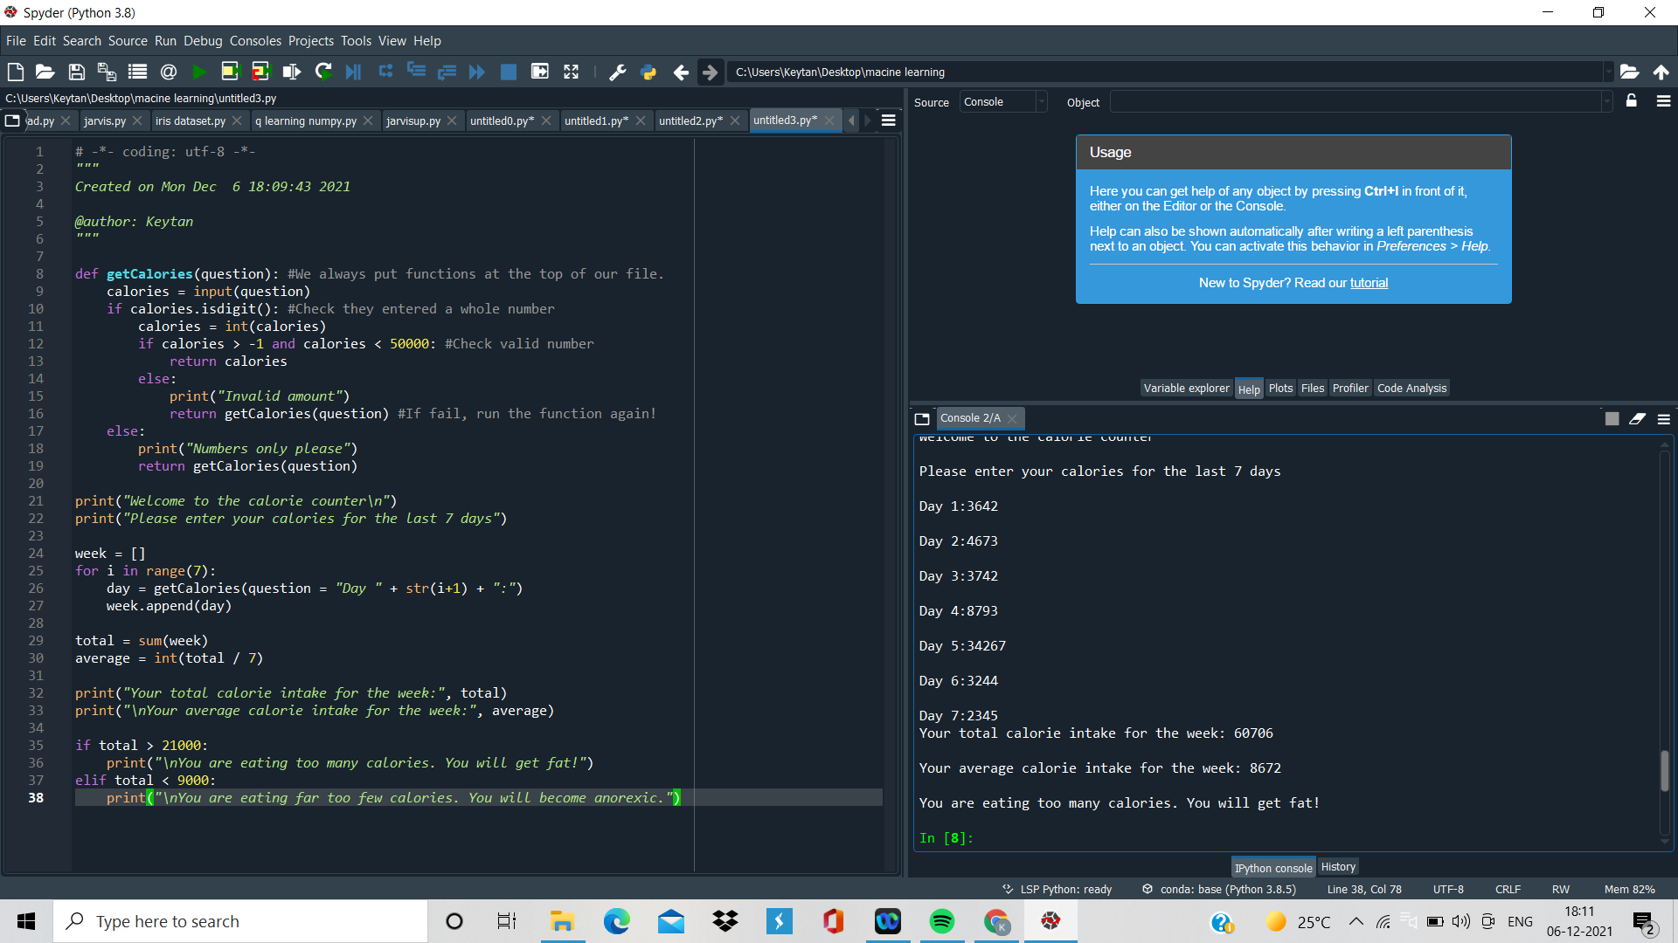

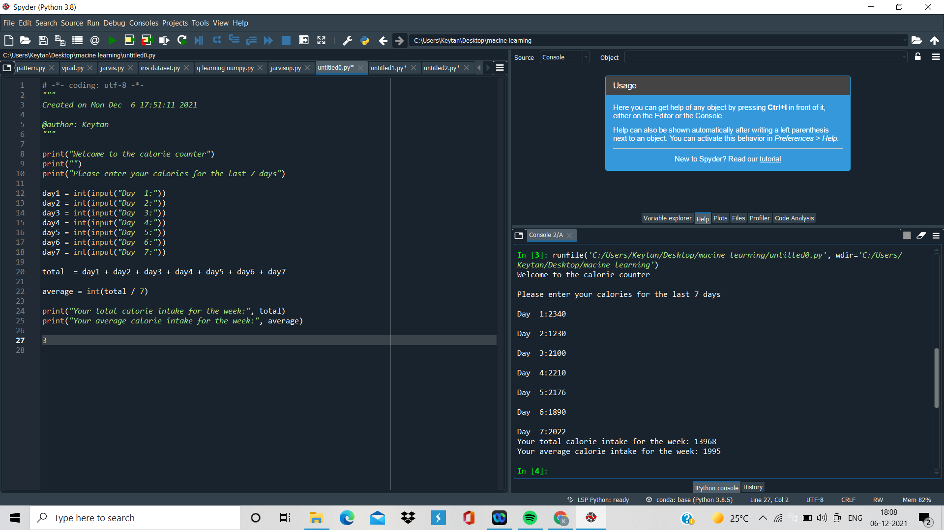

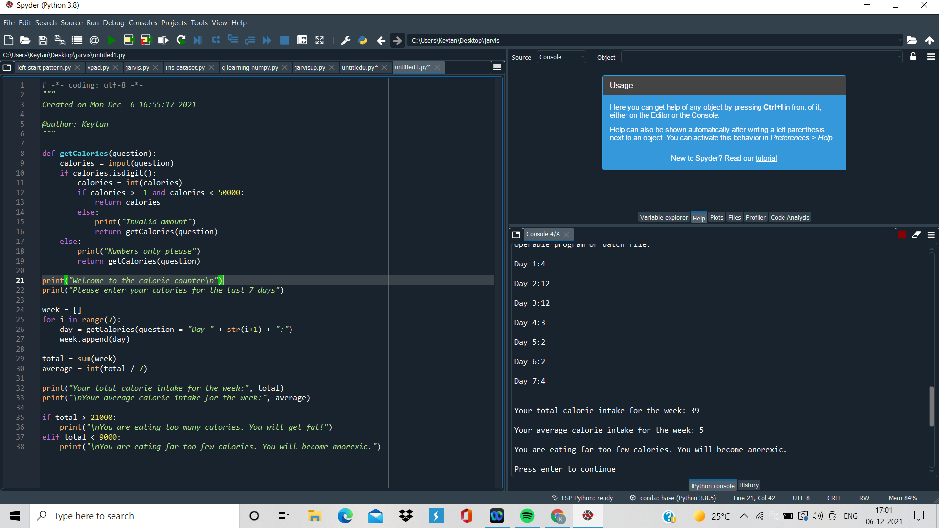

**Future Improvement: I will make software which count calories and give you proper guidance what you eat or not.**

1. **Jarvis Ai app**

**This application makes things easy for sunita. And it will give the notification for her daily task. It will work like a reminder. If you set your daily work in Jarvis notification assistant it will remind her according to time. I have used python for making this application. Its also work like menu driven program.**

**######### Drink water reminder####**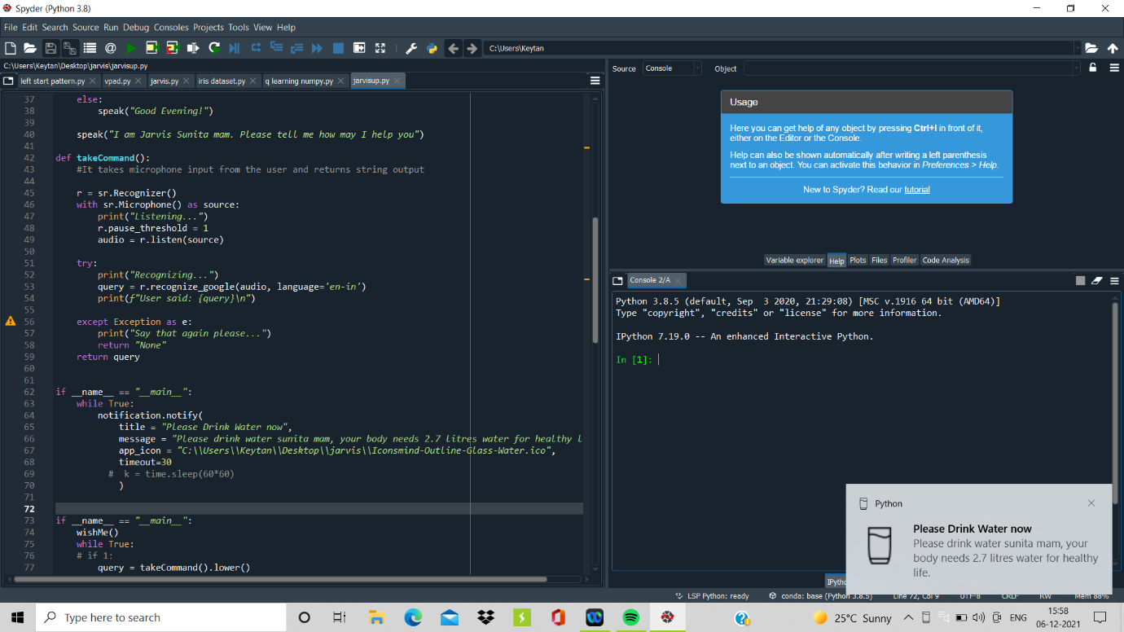

**####3 counting body mask index regularly#######**

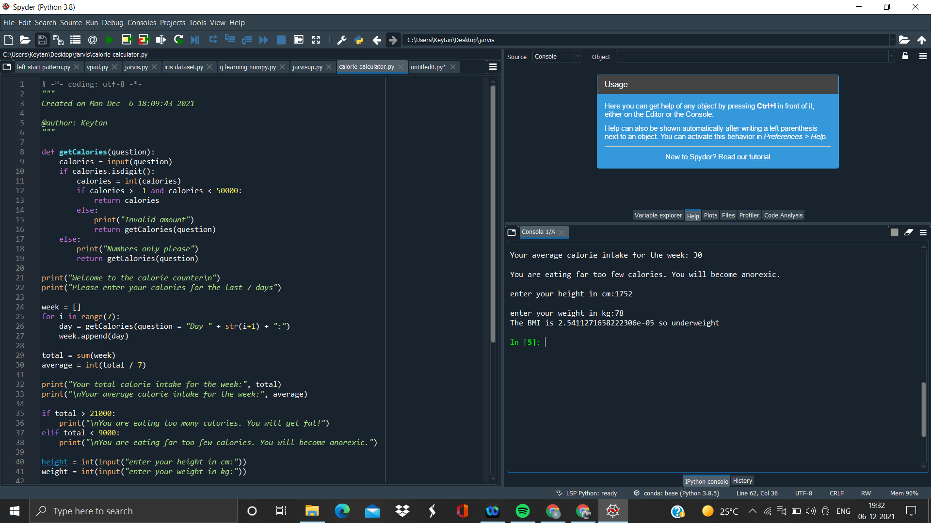

**Like this reminder you can set lot of notification in applicaton. For example you can set dinner time, launch time, exercise time, yoga time .**